

DESIGN AND SIMULATION OF LOCAL AREA NETWORK USING CISCO PACKET TRACER

(CSC455 - Networks 2)



June 21, 2021

Team MEMBERS:

1. Abanoub Goerge
2. Mai Mahmoud
3. Nour Bahaa
4. Ibrahim Fawzy

Supervised by:

Doctor Islam Tharwat

Eng. Ahmed Hazem

**Screenshot of the topology**

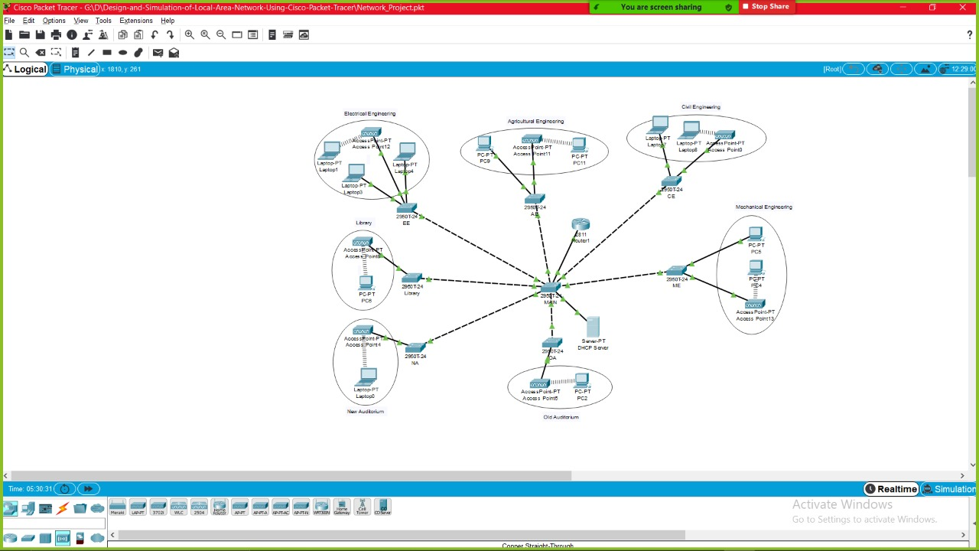

**Configuration Screenshots**

**Router**

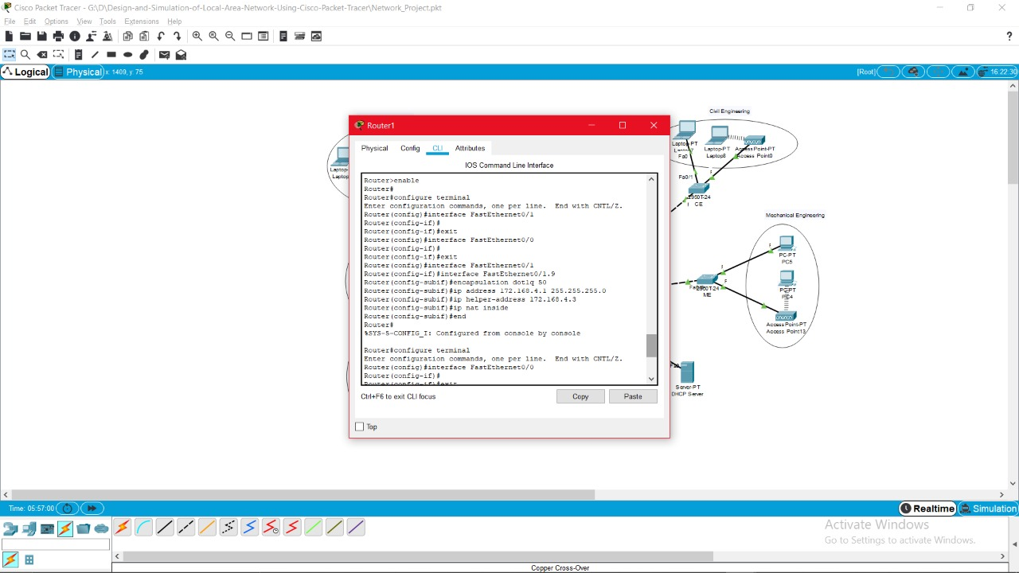

**DHCP**

**“DHCP Config”**

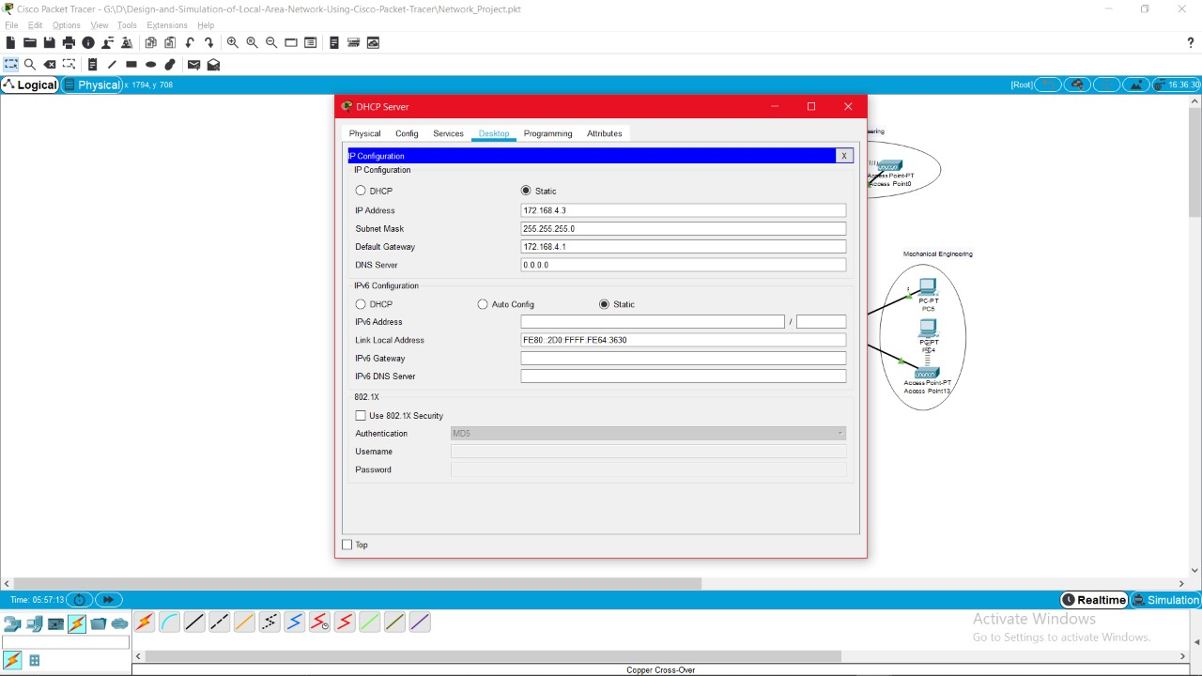

**“VLan Pool”**

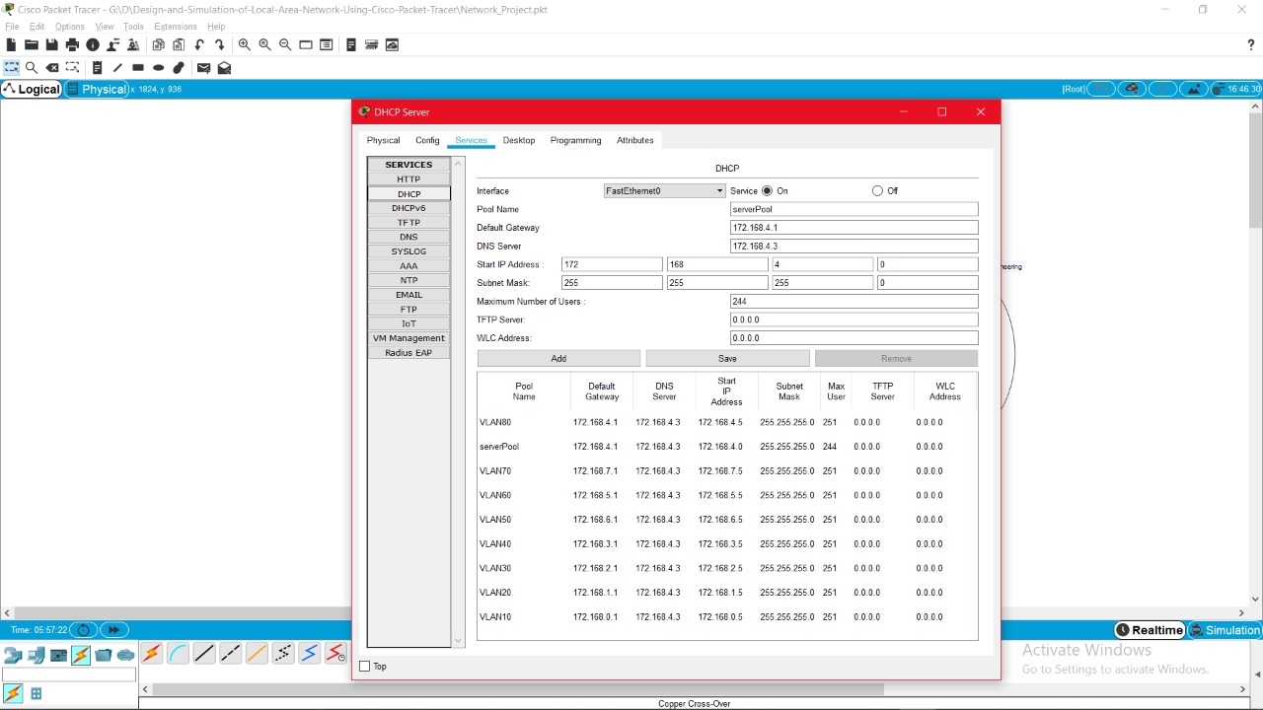

**VLans**

**(Elictrical 10)**

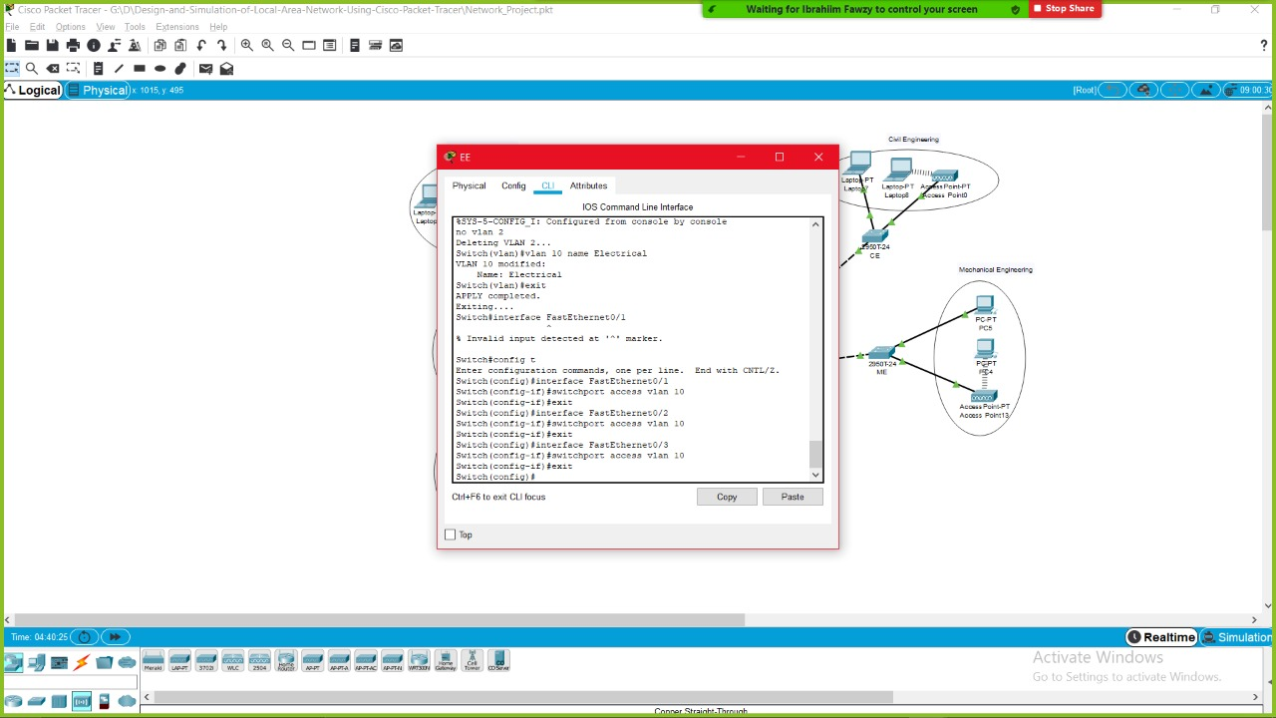

**(Agriculture 20)**

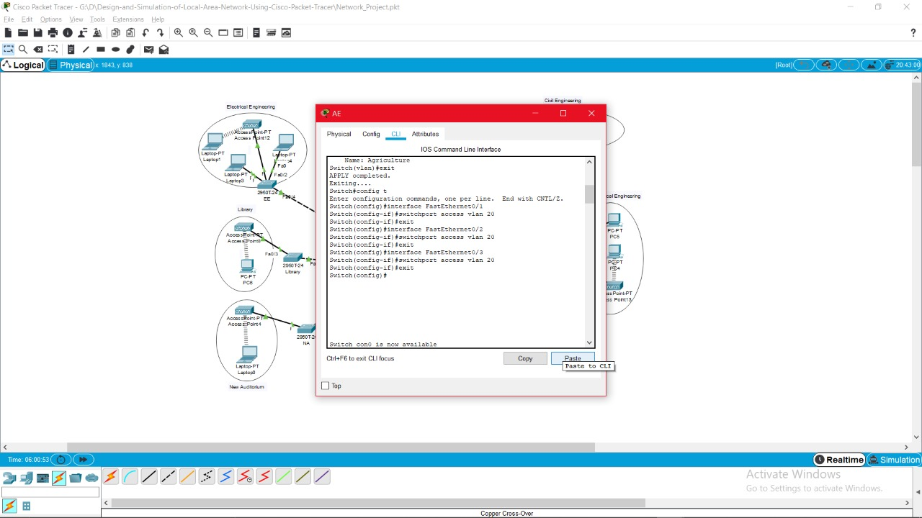

**(Civil 30)**

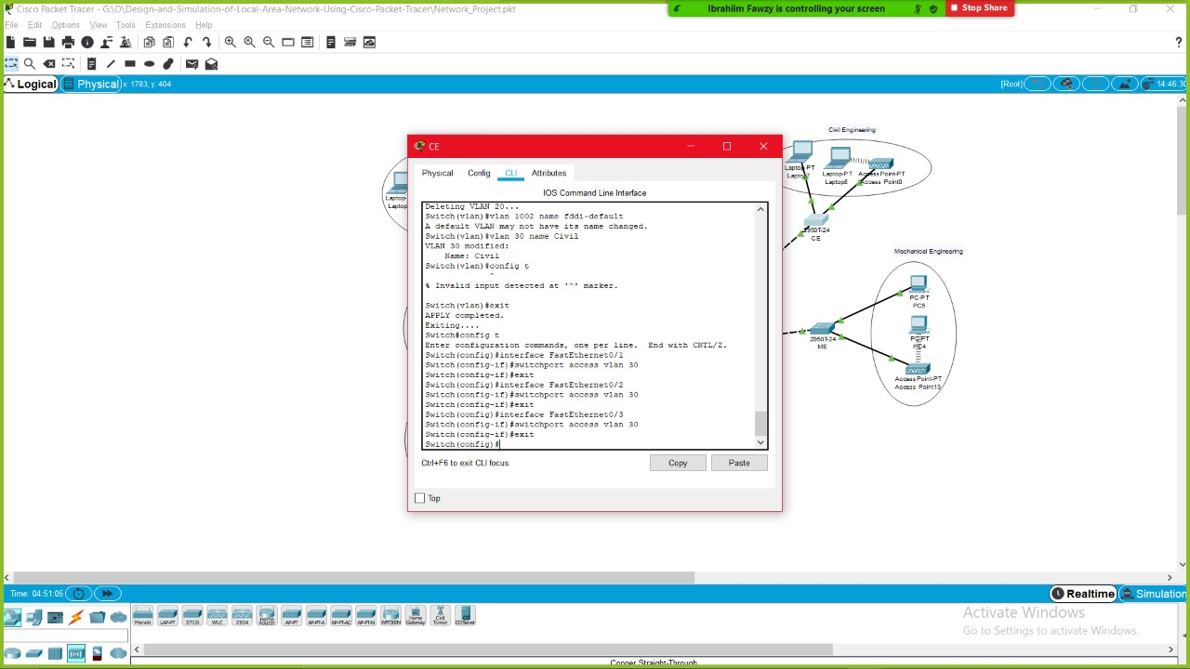

**(Mechanical 40)**

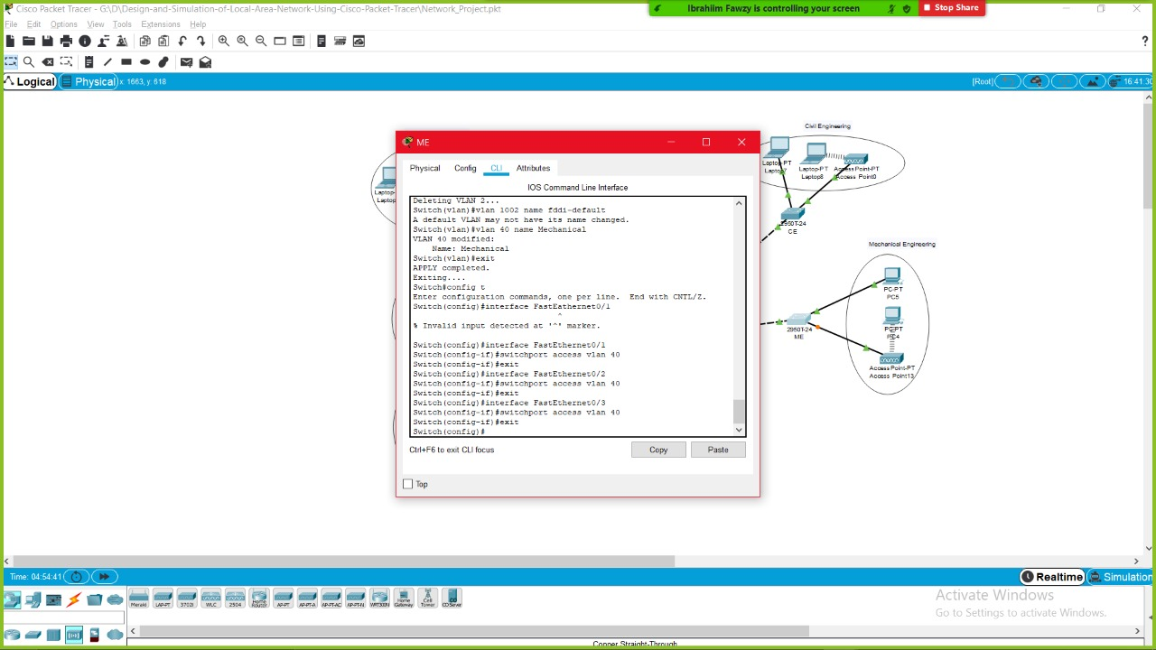

**(Network 50)**

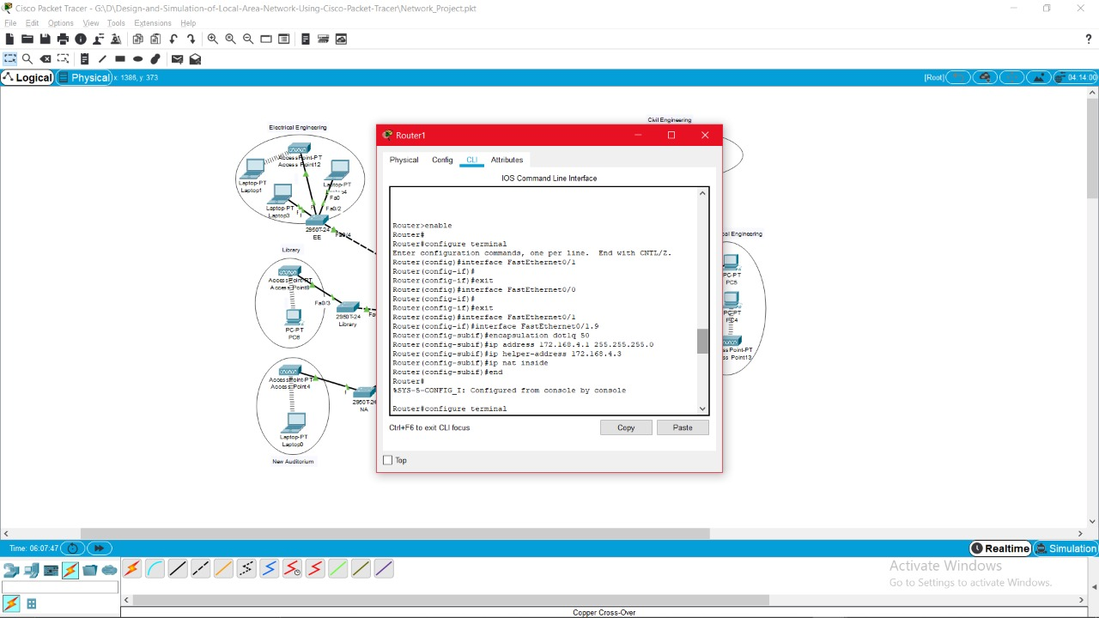

**(Old 60)**

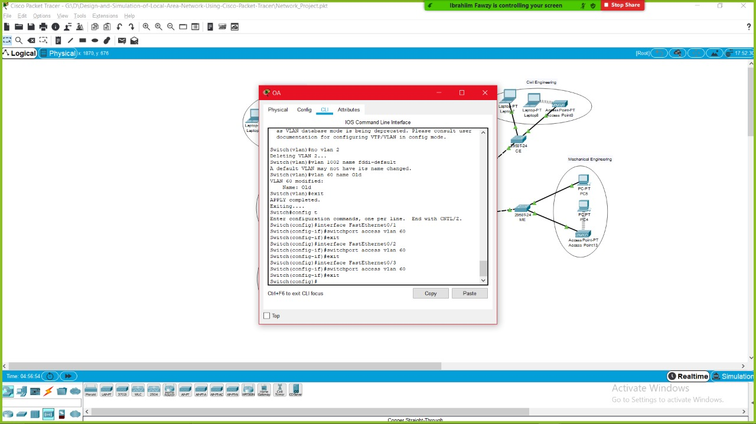

**(New 70)**

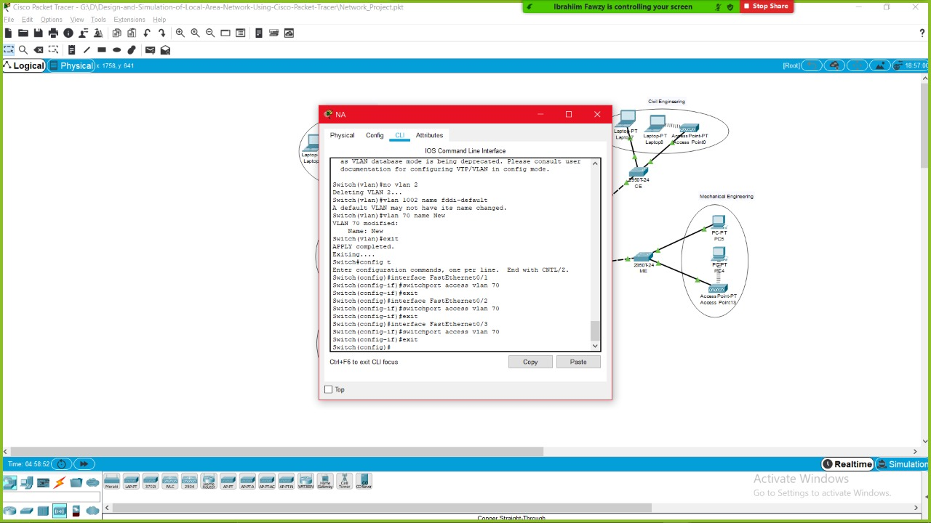

**(Library 80)**

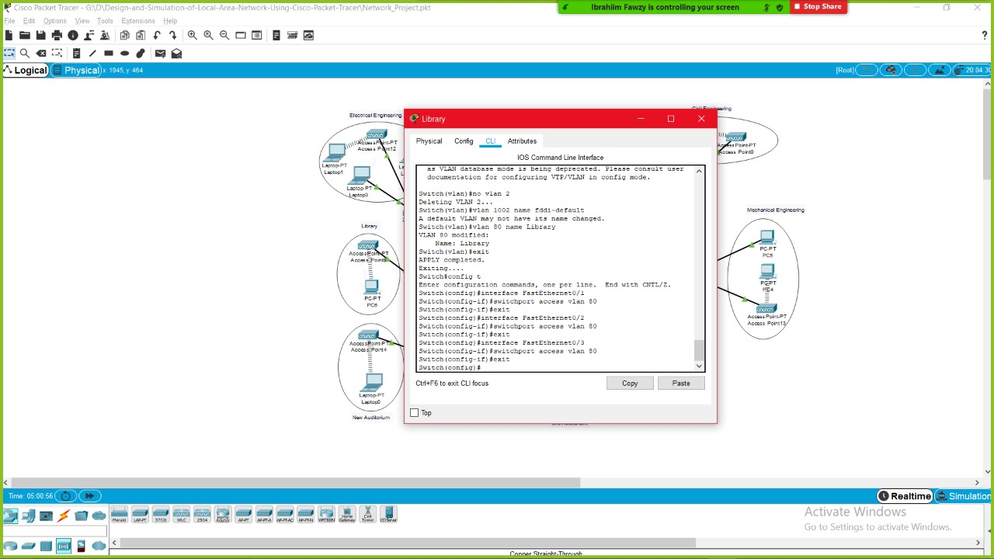

**GitHub**

[**https://github.com/BonyGeorge/Design-and-Simulation-of-Local-Area-Network-Using-Cisco-Packet-Tracer**](https://github.com/BonyGeorge/Design-and-Simulation-of-Local-Area-Network-Using-Cisco-Packet-Tracer)

**Thank You 😊**